Hornsby Lions Netball Club
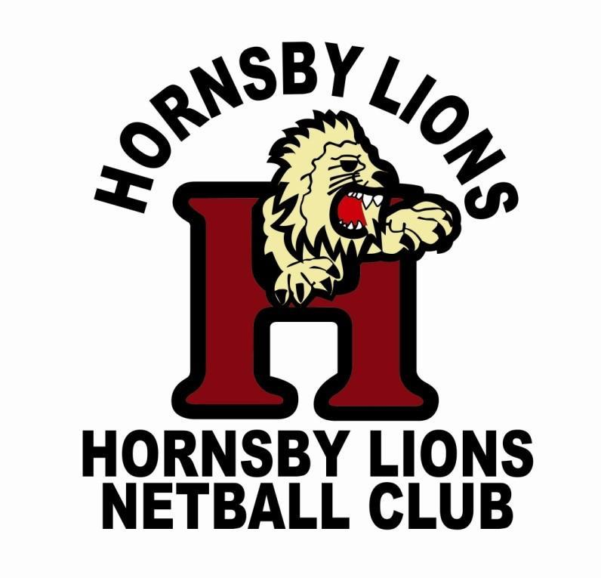

By-Laws
updated August 2023
Contents

Table of Contents
- Code of Conduct 3
- Day Competition Registration 3
- Night Competition Registration 4
- Late Registration 5
- Fees 5
- Duties of the Committee 7
- Uniforms 12
- Club Expenditure 12
- Attachments 15

Code of Conduct

  - All members, parents, guardians and spectators shall abide by the NSW Netball Association Ltd Codes of Conduct.

  - Umpires performing umpiring duty on behalf of the Club in the following categories:
Junior – who shall have reached 13 years of age at 31 December of that year to umpire a junior game,
Senior – who shall have reached the age of 16 years of age by 31 December of that year, except in the case of exceptional ability as deemed by HDNA.

Day Competition Registration

  - All members shall become a Registered Member by:
    - completing the Club’s individual registration form as indicated on the Club’s website and paying all registration fees as detailed in rule 5 except where alternate arrangements have been made in writing with the registrar. .
  - Playing Members may register as an individual player who shall be placed in a team with a grade equal to the player’s experience, as deemed by the Registrar, or attend grading where the players’ ability will be assessed by an independent Sub-Committee known as the Grading Committee and placed into a team equal to the player’s experience.
  - Playing members may also register as a block team who shall be placed into a grade equal to the teams’ experience as deemed by the Registrar upon confirmation of registration and paid fees by all players. Block teams shall consist of the following:
    - No less than 7 registered players
    - A team manager
    - a team coach (if teams are in junior or cadets grades)
  - Grading & Playing Guidelines – Attachment A

Out of Season Competition Registration

  - Registration for other Competitions (example Spring Competition or Night Competition) is deemed by the Club to be played in Social Teams.
- It is up to the Social Teams to organise registration and all that is necessary to play in accordance with HDNA requirements of the Competition.

Late Registration

  - Late registration prior to the commencement of the competition will be accepted by the Registrar no later than the date advised by the Registrar by:
- completing the Clubs individual registration form on the Netball NSW online platform , or
- completing the Clubs team registration form on the Netball NSW online platform for
Night Competition.
- paying all fees as described in rule 5.
- Late registrations will be dealt with in line with the HDNA By -Laws

Fees

Financial Members
    - Playing Members registering prior to the commencement of the competition or later registering up to the end of Round 1, shall pay 100% of the fees as described in the Constitution.
    - Early bird discounts can be applied prior to close of registration date at the discretion of the Committee.
    - Playing Members registering after the completion of Round 1, as determined by HDNA, will be charged:
      - the registration fees set by HDNA, plus
      - the annual Insurance levy included in HDNA fees as described in the Constitution plus
      - the fees as described in the constitution
    - Non Playing Members - Registration fees to be paid to HDNA for non playing members shall be paid by the Club on behalf of the Non Playing Member.
    - Life Members – do not pay fees.

Refund of Fees
    - Members may be eligible for a refund of registration fees under the following circumstances:
      - the Committee is unable to place the Player in a team prior to the registration date set by HDNA, or
      - the Committee is unable to identify sufficient players to make a team of seven (7) prior to the registration date set by HDNA.
      - the Team Manager of a Social or Night Competition Team are unable to identify an umpire prior to the registration date set by HDNA.
      - the member is deregistered prior to the date set by HDNA for lodgement of NSW Membership listing, and
      - HDNA provide a refund of fees
    - Members eligible for a refund of fees may be refunded:
      - for Winter Day competition:
      - prior to registration with HDNA, 90% of the registration fee.
      - after registration with HDNA, and prior to the commencement of the competition, 90% of the registration fee less any fees and/or insurance costs HDNA are unable to refund.
      - for Night competition:
      - prior to registration with HDNA, 90% of the registration fee will be refunded.
      - after registration with HDNA, 90% of the registration fee less any fees and/or insurance costs HDNA are unable to refund, less the umpiring levy for the period from commencement of the competition to the date of deregistration.

Duties of the Committee:

President
It is the duty of the President to:
    - oversee the administration of the Committee and the Club under the Clubs Constitution and By-Laws and the Constitution, Rules and By-Laws of the HDNA and Netball NSW.
    - liaise with the Executives of HDNA.
    - preside as Chairperson at meetings.
    - make and manage bookings for:
      - grounds or appropriate venues for:
        - Club meetings and AGM when required
        - Registration
        - Presentation
        - Training
        - Grading day
        - Net Set Go Clinics
        - Sundry bookings

Vice-President
It is the duty of the Vice President to:
    - assist the President in overseeing the administration of the Committee and the Club under the Clubs Constitution and By-Laws and the Constitution, Rules and By-Laws of the HDNA and Netball NSW.
    - preside as President in the absence of the President.
    - order trophies and/or order/purchase prizes for Presentation
    - manage the organisation of the annual Presentation Night
    - Organise Club Photographs where required:
- book and manage photographer
- liaise with HDNA for approval to hold photo day at the Association
- prepare and communicate roster
- prepare and dispatch photo envelopes to each team Manager and/or Coach

Secretary
It is the duty of the Secretary, or a person nominated by the Secretary, to:
    - attend to the Clubs correspondence by:
      - maintaining a register of all correspondence – in and out, and
      - actioning/on forwarding for action as required:
    - keep minutes of meetings, including at the AGM.
    - Publish a Newsletter at appropriate times through the season.
    - manage Club Register of member by:
- distributing newsletter to Club members
    - maintain and issue the Clubs’ calendar.
Maintains other Club records as required.

  - Treasurer
It is the duty of the Treasurer of the Club to ensure:
    - that all money due to the Club is collected, received and receipted, including from all players/club members and any monies due from outside sources such as deregistration of players from HDNA.
    - that all payments authorised by the Club are made, and
    - that correct books and accounts are kept showing the financial affairs of the Club, including full details of all receipts and expenditure connected with the activities of the Club
    - keep a written record of fee payment agreements
    - quarterly budget review are undertaken with the President and/or Committee
    - relevant financial returns are lodged in a timely manner with Office of State Revenue
    - organise for an annual independent audit
    - act as Public Officer
    - process refunds once approved by the registrar and HDNA (where relevant)

Registrar
It is the duty of the Registrar of the Club to:
    - be first point of contact for registration enquiries
    - collect, collate and maintain a register of all information contained on Club registration forms for Day , including:
      - playing members
- non playing members
- umpires
- coaches
- life members
    - file child protection forms with season’s registration forms when received from registration day
    - complete HDNA registration
    - attend HDNA Registration night to submit team registrations
    - Submit late player registrations to HDNA in line with the HDNA By-Laws
    - submit deregistrations accept and submit further late Registrations to HDNA for Competition as required by HDNA
    - Act in the role of grading coordinator – This does not mean to grade players but to coordinate the process only.

Coaches Coordinator
It is the duty of the Coaches Coordinator to:
    - obtain team lists off the Registrar
    - scout and find coaches for all teams
    - obtain Working With Children Checks for each Coach and save records
    - email coaches team lists and ensure the coaches:
      - contact players and develop mechanisms to contact players through season
      - confirm time suitable for training
      - ensure all players have access to a uniform
    - liaise with Coaches and allocate training courts & times
    - liaise with the Uniform/Equipment Convenor to distribute and collect kitbags at the start and end of each Winter Day competition.
    - provide coaches with the HNDA competition handbook and team contact list.
    - register Coaches for HDNA Coaching clinics if they are interested
    - Ensure that Managers are allocated to each teams as soon as teams are formed.
    - Be the point of contact if parents are not happy with coaching or issues arise.
    - Recruit new coaches each year.

Uniform/Equipment Convenor
It is the duty of the Uniform/Equipment Convenor to:
    - maintain each team kit bag –ensuring that each bag is sufficiently stocked.
    - maintain a register describing what is in a coaches kit bag and ensuring that each coach signs for the bag by Round 1 of the Winter Day Comp season.
    - contacting all coaches within two weeks of the last day comp match (Grand Final Day) to arrange return of kit bags to the Club
    - manage the order & purchase of all new necessary equipment ensuring sufficient stock is maintained to meet the clubs needs ensuring the approval is granted for purchases above the purchase limit as described in the by- laws.
    - distribute uniforms and equipment prior to the commencement of each competition as required
    - liaise with the Registrar to ensure sufficient number of uniform are in stock for new players
    - collect payment for uniforms and issue receipts
    - ensure equipment is maintained in good order
    - ensure all equipment is returned to the Club at the end of each Competition
    - maintain an up to date register of equipment and uniforms and present this at each committee meeting
Umpires ConvenorIt is the duty of the Umpires Convenor of the Club:
    - to:
      - recruit Umpires for all Senior and Junior teams
    - to ensure all Club teams are covered by appropriately qualified u mpires
    - ensure reimbursement is appropriate for teams grade as per the by-laws, and
    - to provide HDNA with Umpires details, and
    - maintain a register of umpiring duties covered throughout the season to
    - enable reimbursement to Umpires
    - ensure Registrar is updated with change of grades for Umpires for
    - inclusion in Club files
    - liaise prior to the commencement of Competition, with all Umpires to discuss and remind them of:
      - Umpires, Players and Spectators Codes of Conduct
      - Commitment to Umpiring
      - Blood Rules
      - Umpires Uniform
      - Umpires Clinic and Exams available
      - Reimbursements
      - Roster
    - monitor and support all umpires during the season wherever possible
    - liaise with HDNA and the Club to clarify any rules

Fundraising Officer
It is the duty of the Fundraising Officer to:
    - coordinate any fundraising efforts
      - All fundraising projects are to be discussed and approved by the committee before commencement

Delegate to HDNA
It is the duty of the Delegates to HDNA of the Club to:
    - represent the Club at the HDNA Council Meetings and Annual General Meeting, ensuring the Club is not fined due to non-attendance
    - vote on behalf of the Club with the best interests of the Club in mind at the HDNA Council Meetings and Annual General Meeting
    - take and distribute Council minutes to the Club at the next Club meeting

Team Managers
Each team shall appoint a team manager, whose role shall be:
    - Act as liaison between the team and the Club committee
    - Liaise with the coach regarding training sessions and player availability
    - Organise for someone to score at each game
    - Arrange and manage helpers as required by HDNA for allocated club duty day(s).

Media Publicity Officer
It is the duty of the Media Officer to:
    - Promote the Club and the Clubs activities.
    - Update information that has been sent by the Secretary on Social Media outlets .
    - Update any other websites that are accessible by the Club and the Club’s members.
    - Contact schools or other local clubs to recruit new players each year for the Winter Competition.
    - Place banners strategically around the local area and arrange for collection.

Uniforms

All players must wear the uniform registered with HDNA which consists of:
  - female players – Hornsby Lions Netball dress in club colours. Cropped Lions shorts or dark scungies.
  - white socks that cover the ankle and are visible above the shoe.
  - suitable white soled sports shoes.
  - In the event of cold weather at play time, Players may wear a long sleeve navy blue top and black leggings .

Club Expenditure

  - The Club’s money can only be spent, without prior authority, by the Executive Committee (as defined in the Constiution) . This expenditure is limited to $150 for any one transaction in any 24 hour period. Expenditure in excess of this amount must be voted on and approved as explained in 8 (2).

  - Any other members of the Committee, including those committee members listed above, can commit to or actually spend the Club’s funds with prior approval. This approval must be granted at a general meeting, or via E-mail. A majority of the
committee OR all members of the Executive Committee, except if the requestor is a member of the Executive, then a majority of the committee must approve. If approval is granted via E-mail, the Committee member requesting the funds must then inform all remaining committee members of the approval. All receipts for expenditure must be submitted to the Treasurer within 7 days of the expenditure. If the Committee member who is asking for approval is the Treasurer, then the Treasurer must inform the Executive when the expenditure has occurred.

  - Committee members who fulfill their role may have their attendance fee waived for the Club’s annual Presentation Night. This must be voted on and approved by the Committee prior to Presentation Night.

  - The Club has a tradition of awarding committee members Hornsby Lions embroidered Club shirt/jumper/jacket after one year’s service to the Club. The cost of this shall be borne by the Club.

  - The Club has a tradition of awarding members of a netball team when that team plays in a grand final with a special gift. The gift shall be decided each year by the Committee.

  - The Club will pay for a Hornsby Lions jacket for the Coach of each team. This jacket may be replaced at the discretion of the Club after 4 years use.

  - The committee must set or re-confirm the payments for umpires at the AGM. At the time of writing (December 202 3) these payments are as follows:

New umpires - $10 per match
Umpires Certificate (UC) qualified - $15 per match Umpires with National C (< 1 year experience) - $20 per match Umpires with National C (> 1 year experience) - $25 per match Umpires with National B or above - $30 per match
However, the Club reserves the right to change these payments if and when circumstances dictate. For example, in recent years, it was very difficult to get umpires for the last time slot. Hence many HDNA clubs paid umpires $25 to umpire games at the time, including Hornsby Lions.

  - The Club will pay umpires from other HDNA or KNA netball clubs, who umpire of behalf of Hornsby Lions, the HDNA standard payment to umpires.

  - Members commit to assisting the Club at least once per annum with any of the following:

- Club duties as defined by HDNA and as assigned by the committee,
- Becoming a member of the committee,
- Club fundraising efforts, and
- other support function as defined by the Club from time to time.

Failure to do so may result in a team fine as determined by the Committee. .

Attachments

Attachment A: Grading Policy

Hornsby Lions Netball Club (the Club) values strong family ties and provides opportunities for its members to play and develop their netball skills in a competitive and supportive team environment and underpinned by fair play and sportsmanship principles.

The Club strives to ensure that all players are treated fairly in a team friendly environment. Grading shall be used by the Club to allocate players to appropriate teams and is designed to maximise each player's enjoyment of netball by providing an appropriate level of competitive and/or social netball.

Players in Under 10 to Seniors will be individually graded where there are sufficient numbers of players in that a ge g roup to form two or more teams.

The Executive Committee, upon considering experience, friendships, family and/or individual request, will allocate players according to a balance of interests. The committee will attempt to grade all players in their year a ge g roup, except where the Executive Committee deems that a player playing in a higher a ge g roup is in the Club's or player’s interest.

